Buatlah topologi seperti gamber berikut:

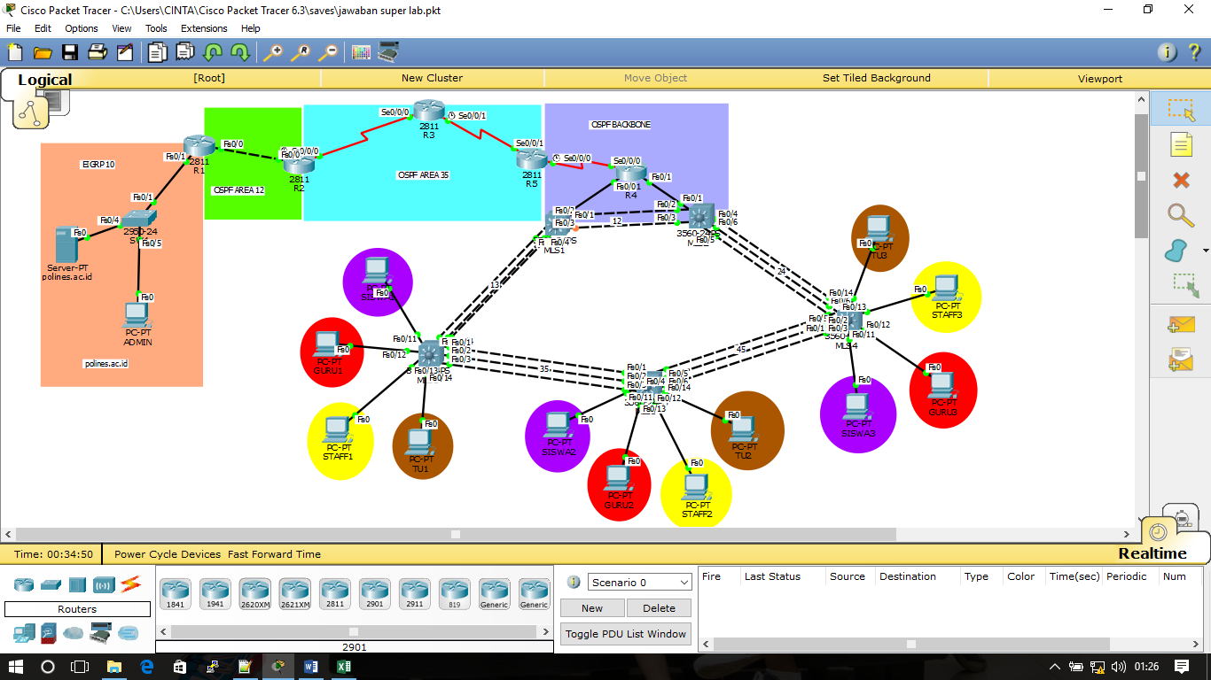

Tujuan:

Vlan SISWA, GURU, STAFF dan TU dapat mengakses domain polines.ac.id

1. Switching

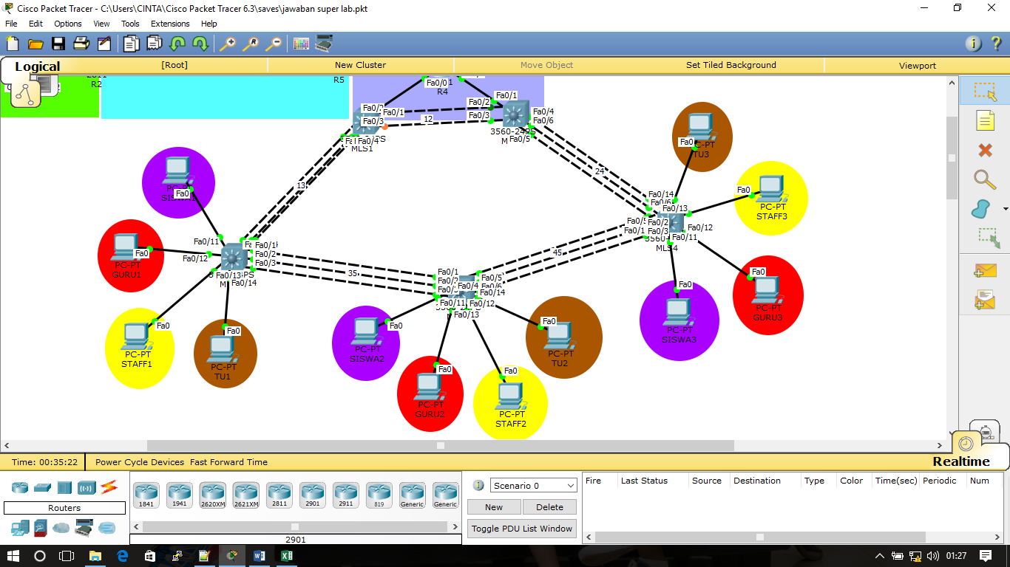

Konfigurasi Etherchannel

|  |  |  |  |
| --- | --- | --- | --- |
| Devices | Port | Channel Group | Mode |
| MLS1 | f0/2-3 | 12 | Static |
|  | f0/4-6 | 13 | Static |
| MLS2 | f0/2-3 | 12 | Static |
|  | f0/4-6 | 24 | Static |
| MLS3 | f0/4-6 | 13 | Static |
|  | f0/1-3 | 35 | Static |
| MLS4 | f0/4-6 | 24 | Static |
|  | f0/1-3 | 45 | Static |
| MLS5 | f0/1-3 | 45 | Static |
|  | f0/4-6 | 35 | Static |

Gunakan MLS 1 sebagai server Vlan.

* VTP domain PCC
* VTP password techcomfest2017

Konfigurasi Vlan

|  |  |  |  |
| --- | --- | --- | --- |
| Interface | Nama | Jumlah host | IP VLSM |
| Vlan10 | SISWA | 1500 host | 172.16.0.0/16 |
| Vlan20 | GURU | 500 host |
| Vlan30 | STAFF | 200 host |
| Vlan40 | TU | 120 host |
| MLS1 ke R4 |  | 2 host |
| MLS2 ke R4 |  | 2 host |

Konfigurasi IP pertama pada MLS1, IP kedua pada MLS2 dan IP terakhir sebagai Virtual IP

Konfigurasi HSRP

|  |  |  |  |
| --- | --- | --- | --- |
| Devices | Interface | Standby | Priority |
| MLS1 | Vlan10 | 1 | default |
|  | Vlan20 | 2 | default |
|  | Vlan30 | 3 | default |
|  | Vlan40 | 4 | default |
| MLS2 | Vlan10 | 1 | 10 |
|  | Vlan20 | 2 | 20 |
|  | Vlan30 | 3 | 30 |
|  | Vlan40 | 4 | 40 |

Konfigruasikan DHCP Server pada MLS1

|  |  |  |  |
| --- | --- | --- | --- |
| Pool | Network | Gateway | DNS |
| vlan10 | IP VLSM 172.16.0.0/16 | Virtual IP | 10.10.10.5 |
| vlan20 |
| vlan30 |
| vlan40 |

IP pertama dan IP kedua tidak termasuk pada IP DHCP yang diberikan ke host

Konfigurasi Interface Vlan pada MLS3, MLS4 dan MLS5

|  |  |  |
| --- | --- | --- |
| Devices | Interface | Vlan |
| MLS3  MLS4  MLS5 | f0/11 | SISWA |
| f0/12 | GURU |
| f0/13 | STAFF |
| f0/14 | TU |

1. Router

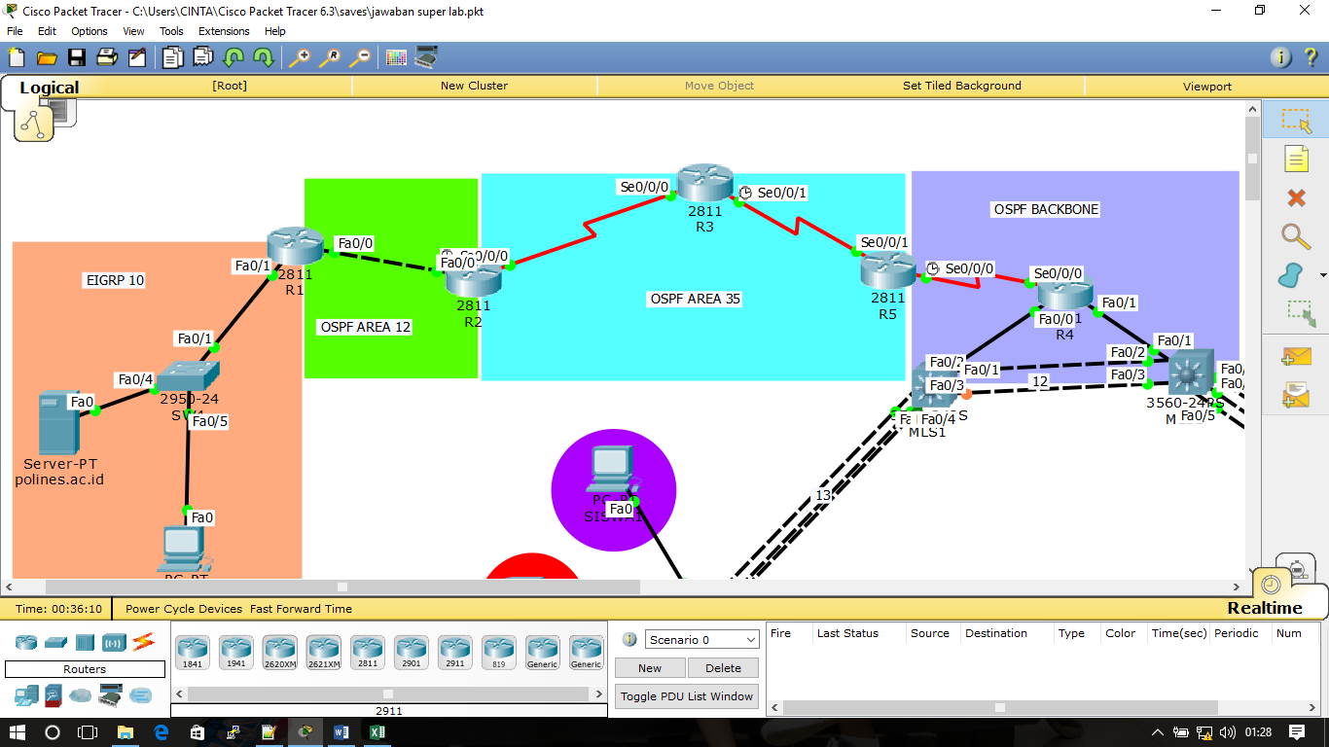

Konfigurasi Interface

|  |  |  |
| --- | --- | --- |
| Devices | Interface | IP Address |
| R1 | f0/1 | 10.10.10.1/24 |
| f0/0 | 12.12.12.1/24 |
| loopback | 1.1.1.1 |
| R2 | f0/0 | 12.12.12.2/24 |
| s0/0/0 | 23.23.23.2/24 |
| loopback | 2.2.2.2 |
| R3 | s0/0/0 | 23.23.23.3/24 |
| s0/0/1 | 35.35.35.3/24 |
| loopback | 3.3.3.3 |
| R4 | s0/0/0 | 45.45.45.4/24 |
| f0/0 | IP pertama  IP VLSM  172.16.0.0/16 |
| f0/1 |
| loopback | 4.4.4.4 |
| R5 | s0/0/0 | 45.45.45.5/24 |
| s0/0/1 | 35.35.35.5/24 |
| loopback | 5.5.5.5 |

1. Routing EIGRP

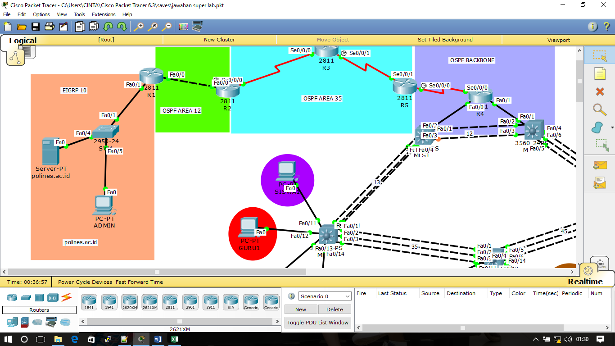

* Konfigurasi EIGRP menggunakan proses id 10
* Konfigurasikan network dengan IP classfull
* Distribusikan Routing EIGRP ke OSPF dengan metric 1 1 1 1 1

1. Routing OSPF

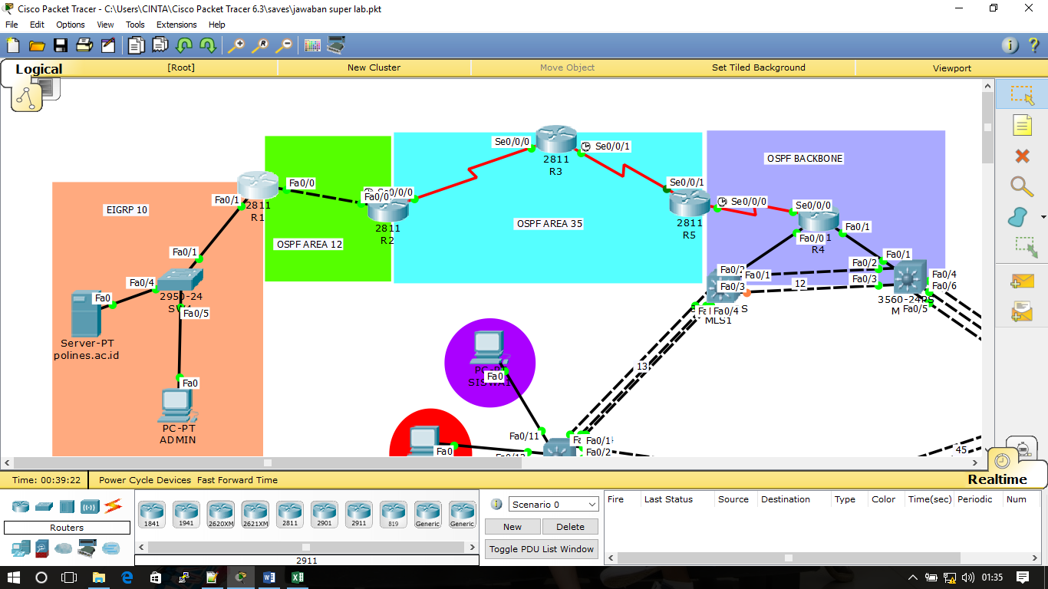

|  |  |  |  |
| --- | --- | --- | --- |
| Source Device | Destination Device | Area | Wildcard Mask |
| R1 | R2 | 12 | 0.0.0.0 |
| R2 | R3 | 35 | 0.0.0.0 |
| R3 | R5 | 35 | 0.0.0.0 |
| R5 | R4 | backbone | 0.0.0.0 |
| R4 | MLS1 | backbone | Classfull IPVLSM  172.16.0.0/16 |
| R4 | MLS2 | backbone |

* Konfigurasi OSPF menggunakan proses id 10
* Alamat IP loopback digunakan sebagai Router id
* Konfigurasi Virtual Link pada OSPF Area 12 dan Area 35

1. Server

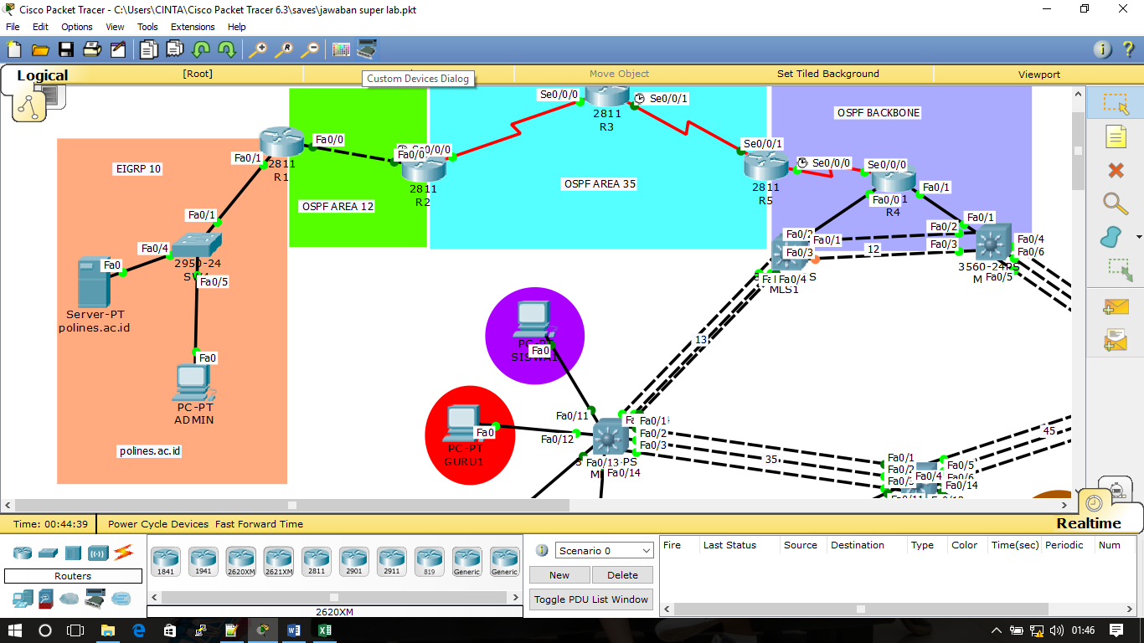

* Konfigurasi Server dengan domain “polines.ac.id”

SELAMAT MENGERJAKAN ☺